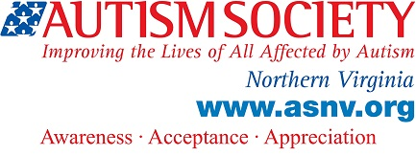

TAP Agenda

July, 9 2016
Taking Leadership in Self-Advocacy

3:00 – Welcome, Sign-in, Introductions (Name Tags), Announcements.

3:15 – Discussion on Community Leadership Opportunities

4:00 – Social Hour

4:55 –Closing Remarks

5:00 – Adjourn

Further Resources

Interagency Autism Coordinating Committee- The IACC is the government committee that coordinates research on autism for the Department of Health and Human Services. Input from Autistic adults is always welcome and needed. The next IACC meeting will be July, 19 from 9:00 am to 5:00 pm at the National Institutes of Health, Building 31.
https://iacc.hhs.gov/meetings/iacc-meetings/2016/full-committee-meeting/april19/

They are accepting online public comments on autism research until July, 29.
Please take a look at the online survey and let the government know what you think are the most important aspects of autism they should research!
https://iacc.hhs.gov/meetings/public-comments/requests-for-information/2016/strategic-plan.shtml

Autistic Self-Advocacy Network- ASAN offers resources and workshops for anyone interested in getting involved with autism policies.
http://autisticadvocacy.org/
The local chapter of ASAN for the Washington DC Metropolitan area is ASAN-DC.

Getting involved with non-profits- Here is an article on how to join a board: http://www.huffingtonpost.com/greg-vermeulen/how-to-get-on-a-nonprofit_b_3787669.html

Also, ASNV has a lot of opportunities to serve on committees! Talk to me if you would be interested in joining one!

