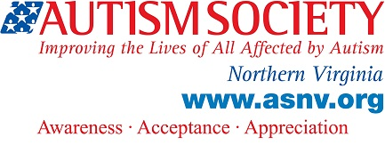

TAP Agenda

February, 13 2016
Living Independently

3:00 – Welcome, Sign In, Introductions (Name Tags)

3:15 – Discussion on Independent Living

4:00 – Social Hour, Game of Life

4:55 – Announcements, Closing Remarks

5:00 – Adjourn

Resources for Independent Living

Disability or Autism-specific Groups/Organizations

- ENDependence Center of Northern Virginia (ECNV) - http://www.ecnv.org/index.html
- disAbility Resource Center - http://www.cildrc.org/
- The Arc of Northern Virginia - https://thearcofnova.org/
- Service Source - http://www.servicesource.org/
- Virginia Department for Aging and Rehabilitative Services - http://www.vadrs.org/

Recommended Books

- Living Independently on the Autism Spectrum – Lynne Soraya
- Adulting: How to Become a Grown-Up in 468 Easy(ish) Steps – Kelly Williams Brown

